**Problem Statement:**

You work for XYZ Corporation. Their application requires a storage service that

can store files and publicly share them if required. Implement S3 for the same.

**Tasks To Be Performed:**

1. Enable versioning for the bucket created in task 1.

Go to the bucket and then properties tab. Enable bucket versioning

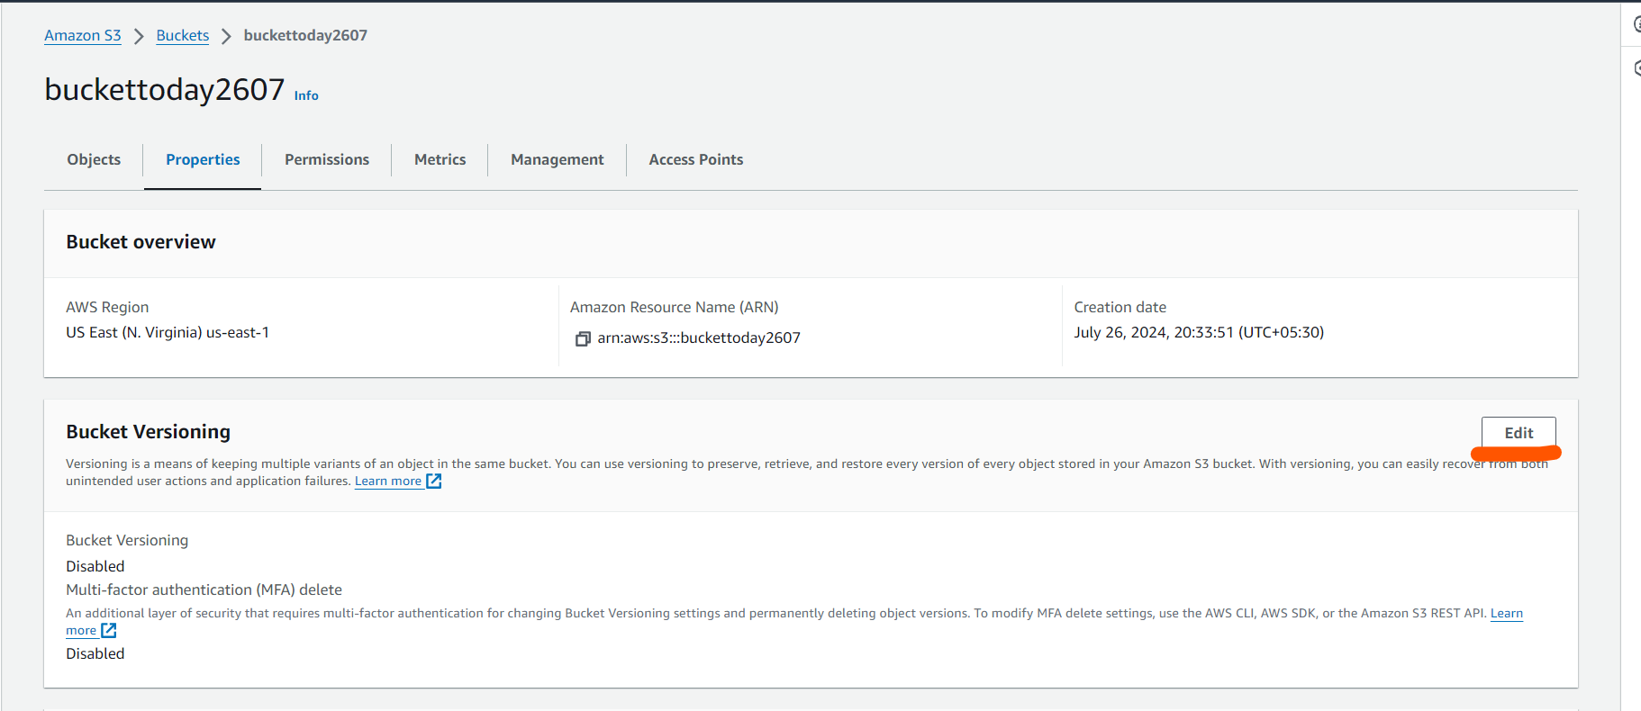

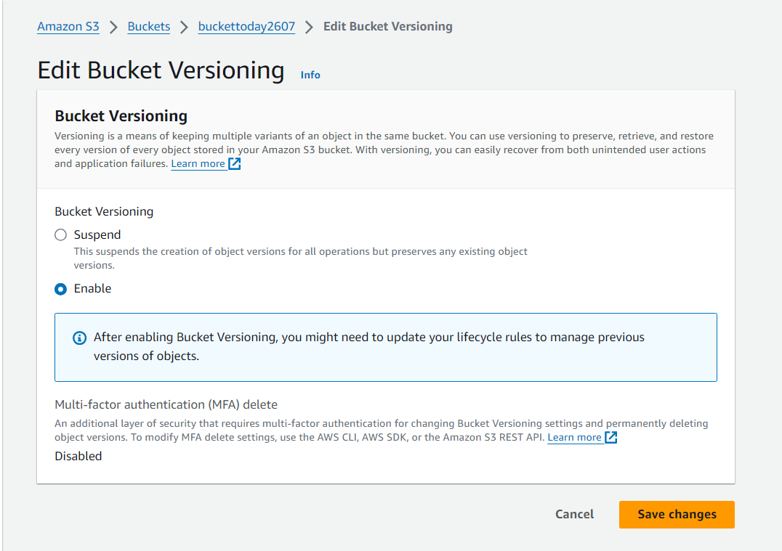

1. Re-upload any 2 files already uploaded to verify if versioning works.

Bucket already have

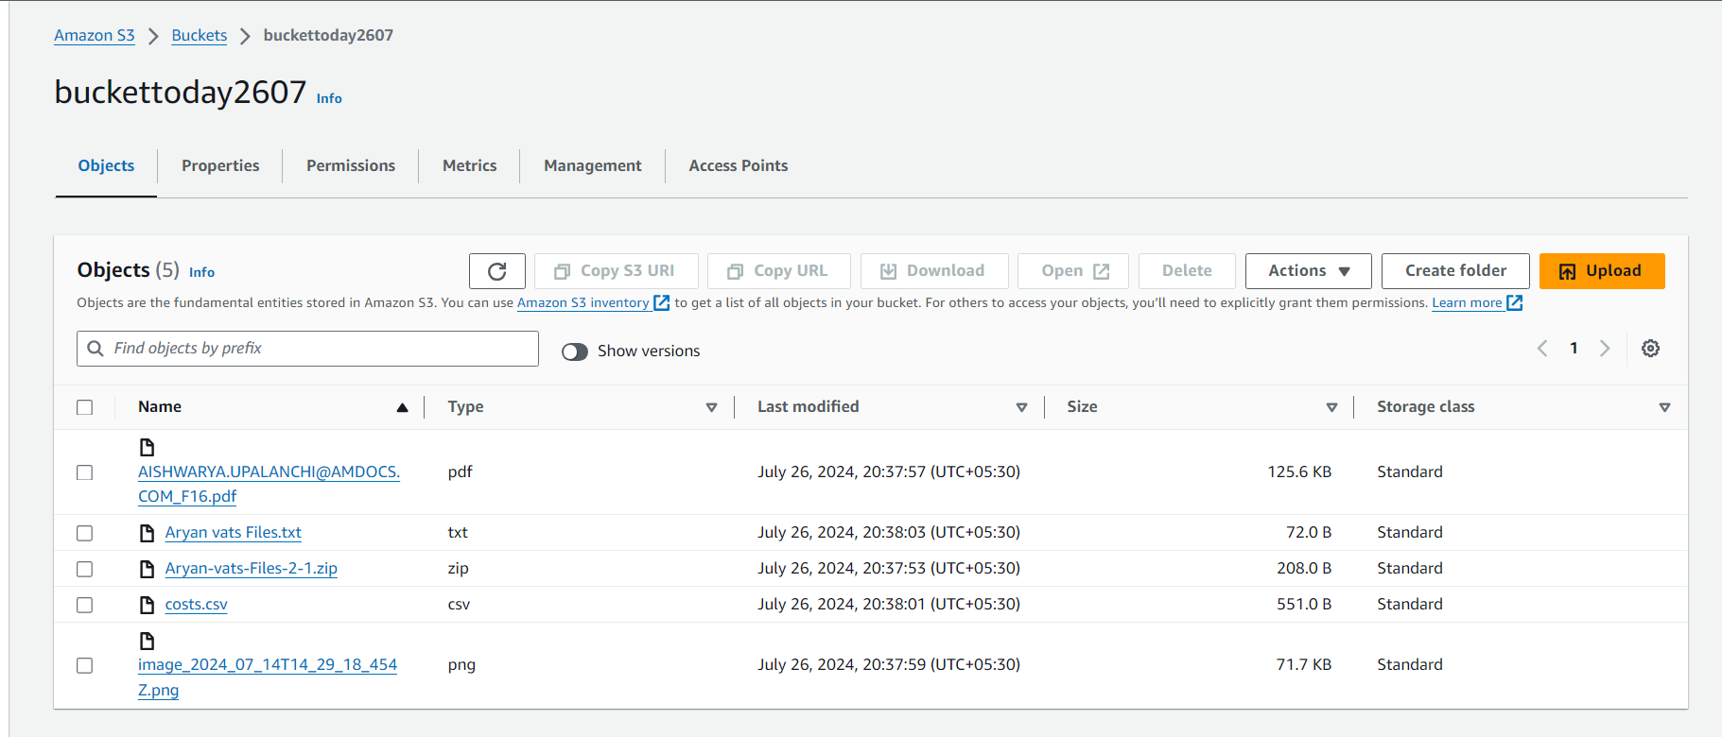

Uploading costs.csv and Aryan vats Files.txt

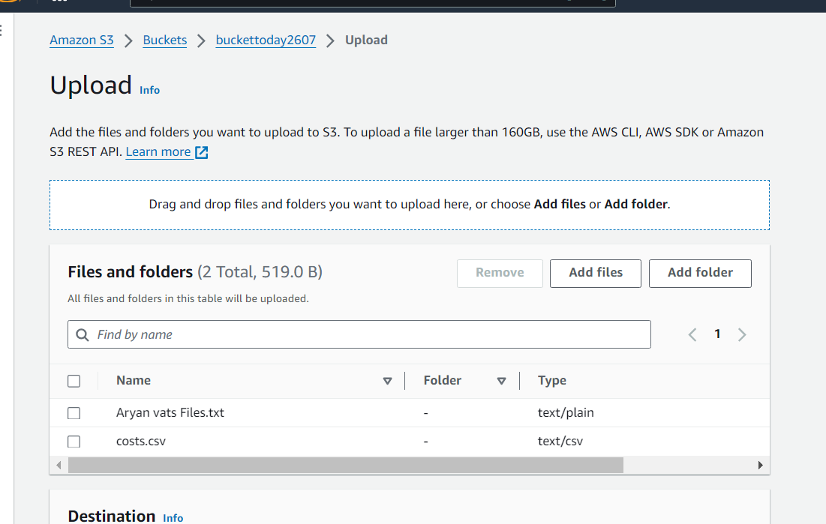

To see versioning of file

